**Activity 7:** Jokes App Navigation

Ryan Scott

Grand Canyon University  
Mobile Game Development

Prof. Shad Sluiter

**Login Screenshot:**

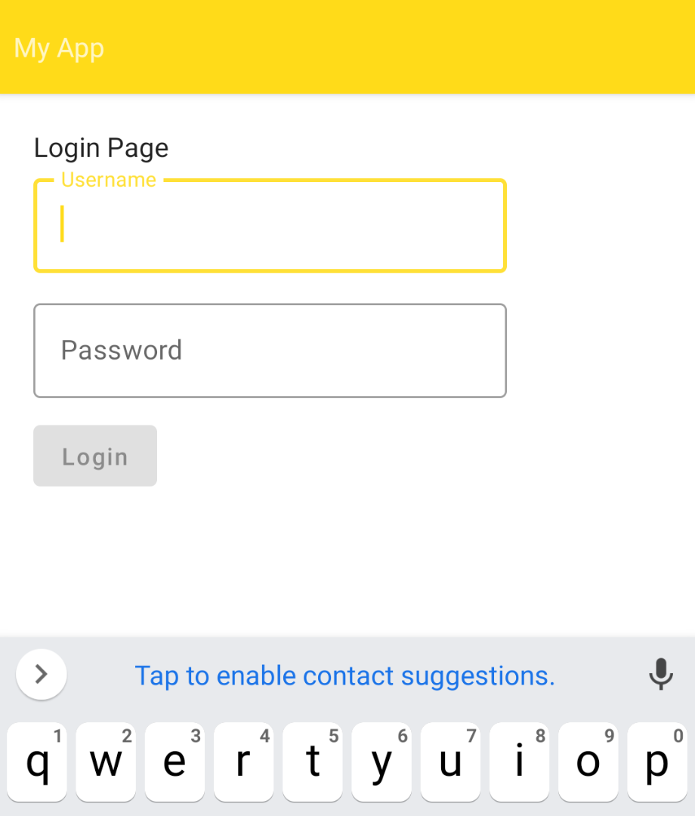

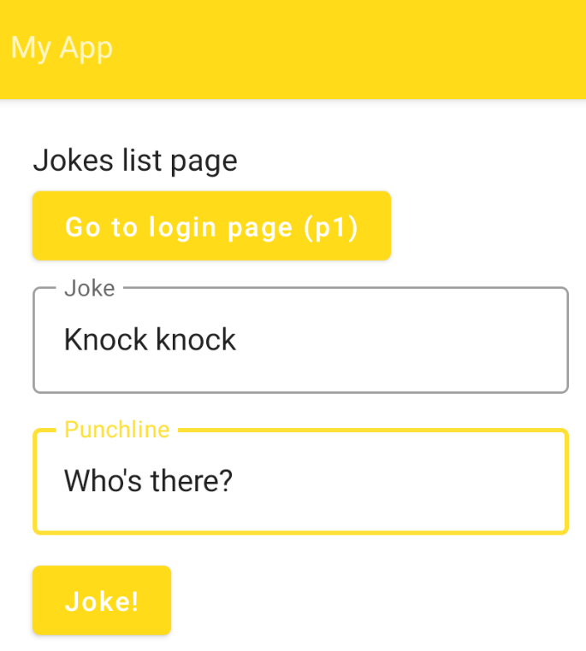

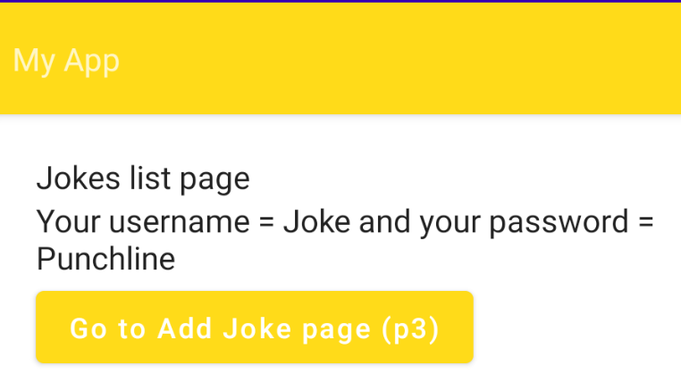

# What I learned

Based on the task that I completed, I learned how to create a three-page application with signup, login, and welcome screens using the Navigation component in Android Studio. I also learned how to customize the color scheme and font choices of my app, as well as incorporate graphics into the design.